|  |  |
| --- | --- |
|  | |
|  | |
|  |  |

|  |  |
| --- | --- |
| Publication type: |  |
| Publication number: | ACC |
| Title: |  |
| Subject: |  |
| Issue: | 1.1.19 |
| Publication date: | 12 February 2014 |
| Total number of pages: | 133 |
| Author: |  |
| Quality Control: |  |

Table of contents

Page #

2. Figures 4

3. References 8

4. Introduction 9

5. About the Operating Manual 9

6. Safety instructions 11

7. Revision history 11

8. Rudiments of the system 12

8.1 Introduction 12

8.2 Elements 12

8.3 Measured and switched elements 13

9. Human Machine Interface 14

9.1 Taskbar 14

9.1.1 Taskbar features: 15

9.1.2 Taskbar buttons 15

9.2 Mimics 20

9.2.1 Free adjustable mimics 20

9.2.1.1 Building the mimic 21

9.2.2 Mimic color usage 24

9.2.3 Colour coding 24

9.2.4 24

9.2.5 Symbols 24

9.2.6 Control elements 27

9.2.7 Pump and generator control elements 28

9.2.8 3-Way valve control element 29

9.2.9 Other control options 30

10. Duty alarm system and alarm handling 31

10.1 Introduction 31

10.2 Design principle 31

10.2.1 Alarm groups 31

10.2.2 Alarm types 32

10.2.2.1 Alarm detection for analogue signals 32

10.2.2.2 Alarm detection for on/off (two state) signals 32

10.2.2.3 Alarm detection for on/off signals with line check 32

10.2.3 Alarm inhibits 32

10.2.4 Attended alarm mode 33

10.2.5 Unattended alarm mode 33

10.2.6 How an alarm is displayed 33

10.2.7 How to acknowledge an alarm 35

10.2.8 When an alarm is not acknowledged within a specific period of time 35

10.2.9 How to silence an alarm (not at ECR) 35

10.2.10 When will an alarm disappear 35

10.2.12 Controls and indications 37

10.2.12.1 Call button 37

10.2.12.2 On-duty indication 37

10.2.12.3 Duty select button 37

10.2.12.4 Panel active button 37

10.2.12.5 On-duty selection 38

10.2.12.6 Watch safety timer 38

10.3 On duty select procedure 39

10.4 Alarm acknowledge procedure 39

10.5 Call function 39

11. Personnel alarm 40

11.1 General 40

11.1.1 Release station 40

11.1.2 Alarm Panel 41

11.1.3 BNWAS 42

11.2 Alarm monitoring and control process 42

11.3 Logbook 44

11.3.1 General 44

11.3.1.1 Logbook colours 44

11.3.2 Logbook functionalities 45

11.3.3 Buttons 45

11.3.3.1 Scroll buttons 45

11.3.3.2 Time period button 46

11.3.3.3 Alarms from all stations button 46

11.3.3.4 Alarm button 46

11.3.3.5 Switching button 46

11.3.3.6 Network button 47

11.3.3.7 Serial communication button 48

11.3.3.8 System button 48

Figures

Figure 9‑1: NavVision taskbar 12

Figure 9‑2: On Screen Keyboard 13

Figure 9‑3: User panel 14

Figure 9‑4: Palette drop-down 14

Figure 9‑5: Group viewer window 15

Figure 9‑6: Alarm mimic 16

Figure 9‑7: Logbook mimic 17

Figure 9‑8: Settings window 17

Figure 9‑9: Mimic button taskbar 18

Figure 9‑10: Empty Mimic 18

Figure 9‑11: Edit Mode 19

Figure 9‑12: Edit Mode Window 19

Figure 9‑13: Mimic Option Window 20

Figure 9‑14: example mimic options 21

Figure 9‑15: Mimic layout 23

Figure 9‑16: Symbol examples 23

Figure 9‑17: Piping intersection and color 24

Figure 10‑1: Alarm groups 29

Figure 10‑2: Alarm scroll buttons 30

Figure 10‑3: Alarms on alarm viewer and taskbar 32

Figure 10‑4: One acknowledged and three unacknowledged alarms (incl. GEA) 33

Figure 10‑5: typical alarm sequence 34

Figure 10‑6: Call button / on-duty indication / duty select button 35

Figure 10‑7: Panel active button 35

Figure 10‑8: Watch safety timer 36

Figure 10‑9: Watch safety timer (remaining time indication) 36

Figure 10‑11: Operating buttons 37

Figure 10‑17: Acknowledge button 37

Figure 11‑1: Deadman Switch Password 38

Figure 11‑2: Release station 39

Figure 11‑3: Alarm Panel 39

Figure 11‑4: BNWAS Panel 40

Figure 12‑83: Logbook button 42

Figure 12‑84: Logbook colours 43

Figure 12‑85: Scroll buttons 43

Figure 12‑86: Time period button 44

Figure 12‑87: Alarms from all stations button 44

Figure 12‑88: Alarm button 44

Figure 12‑89: Switching button 44

Figure 12‑90: Network button 45

Figure 12‑91: Serial communication button 46

Figure 12‑92: System button 46

References

[1] ACC-NavVision-Technical-Description v1.2.17

[2] ACC-NavVision-Operators-Manual v1.6.16

[3] ACC-NavVision-Duty-Alarm-Manual v1.2.10

Introduction

The contains all essential information for the user to make full use of all the features of the AMCS. This manual includes a description of the alarm functions, monitoring functions, control functions and additional capabilities. Also described are contingencies and alternate modes of operation, and step-by-step procedures for system access and use.

About the Operating Manual

This manual contains the following sections:

* Section “Safety instructions” presents warning, caution and note information, which the user should pay attention to.
* Section “Rudiments of the system” defines the basics of the system, which is elementary for further knowledge and understanding
* Section “Human Machine Interface” contains explanation on the look and feel of the visible part of NavVision.
* Section “Duty Alarm System” explains how to work with the AM(C)S system and how the different parts are integrated in NavVision.
* Section “Personal Alarm” explains the work and feel of the different Deadman-systems provided within NavVision.

 *For specific information on interfaces, but also in depth information on here mentioned features, as well as here not mentioned features, we refer you to the specific manuals from NavVision that can be obtained through Imtech.*Abbreviations list

AI Analog Input

AM(C)S Alarm Monitoring (and Control) System

AO Analog Output

COM Communication

CPU Central Processing Unit

DAP Duty Alarm panel

DI Digital Input

DO Digital Output

DM Dead Man’s

ECR Engine Control Room

GEA General Engineers Alarm

GND Ground

GPS Global Positioning System

GRP Group

ID Identification

I/O Input/Output

LAN Local Area Network

LED Light Emitting Diode

LPU Local Processing Unit

MAC Media Access Control

Mbps Megabit per second

NC Normally Closed

NMEA National Marine Electronics Association

NO Normally Open

OWS Operator Work Station

PIN Personal Identification Number

TCP/IP Transmission Control Protocol/ Internet Protocol

TFT Thin Film Transistor

USB Universal Serial Bus

Safety instructions

 *This section provides only a summary of the safety requirements and notes in the following sections. To protect your health and prevent damage to the AM(C)S equipment or vessel, it is essential to read and carefully follow the safety instructions.*

The indications NOTE, CAUTION and WARNING have the following significance:

*NOTE:  
An operating procedure, practice or condition etc., which it is important to emphasize.*

*CAUTION:*

*An operating procedure, practise or condition etc., which, if not strictly observed, may damage AM(C)S equipment or crash NavVision software.*

*WARNING:*

*An operating procedure, practise or condition etc., which, if not carefully observed may result in personal injury or damage to the vessel.*

Revision history

Revisions issued since publication.

|  |  |  |  |
| --- | --- | --- | --- |
| **Issue** | **Date** | **Revision** | **Reason** |
| 1.1.19 | February 10, 2014 |  | initial release |

# Rudiments of the system

## Introduction

The NavVision AMCS exists rudimentary of elements. There are measured elements and switched elements. It is very important that you understand the basic principles of elements. This is essential to understand the behaviour of the program and will help you to understand what you are doing once you get to adjust or fine-tune things within the program.

## Elements

To get a grasp of the element there need to be an understanding what an element is. This is hard to explain as a simple object, merely because there is no unequivocal explanation of an element. It is better to explain the concept “element” by looking at the following examples.

Running

Start

Engine

Failure

Stop

Element: engine

An engine can be an element. You can have inputs and outputs on every element. The element “Engine” can have different kind of I/O. A few examples for the element “Engine” are:

* Start
* Stop
* Running
* Off
* Failure
* Local
* Remote

You can connect all of these actions to the element. For example, you can start the engine, you can stop the engine, you can see if it’s running or in failure, etc.

So, the element “Engine” is not the engine itself but the virtual device that you can adjust or read status from.

To elaborate a bit further, the element “Engine” can consist of multiple other elements. One of these elements can be the element “Oil Temperature”. Don’t confuse this with the Oil Temperature Sensor, which is the actual interface that reads the temperature of the oil. Within the AMCS we work with the Element that shows us, in this case, the temperature-value of the oil.

This element works throughout our system with every part that we monitor or control.

Temperature

Wire break

Oil Temperature

High

Too High

High

Bilge

Too High

Set

Valve

Open

Closed

Reset

Pending

Push

Failure

Auto

## Measured and switched elements

Elements can be divided in measured elements and switched elements. Measured elements are those that give a value to the interface. You can think of oil or water temperature, but also “levels” or “angle” can be measured elements.

Switched elements are the elements that provide an “on or off” an “open or closed” etc. The name speaks for itself.

*: don’t confuse elements with sensors. A sensor is the carrier or interface that provides the element data. An engine can consist of many other elements while the engine itself can be an element too. A fire alarm is an element that can be part of a fire alarm system, but the fire alarm system can be a separate element that can be switched on or off or can show modes or failure etc.*

# Human Machine Interface

The NavVision Operator PC (OPC) Human Machine Interface (HMI) function displays the current state of a physical device on monitor screen by color and/or shape animation.

Moreover when an undesirable state of a device is detected the relevant operator will be notified by means of an audible alarm signal. Messages concerning the alarm are added to the NavVision list of active-/unacknowledged alarms. This list can be displayed on screen by mouse clicking the extensive alarm viewer button, see next paragraph.

The HMI also supports remote platform control. Operators can control the platform (vessel) via the Operator PC (OPC).

The HMI includes the following features:

## Taskbar

NavVision’s main User Interface (UI) element is the taskbar, positioned on top of the main screen. The taskbar is home to the shortcuts to various tasks.

In addition, when an alarm is registered, the right most portion of the taskbar turns a bright red and shows the most recent unacknowledged alarm, the number of active alarms and the total number of unacknowledged alarms. A single mouse click on this portion of the taskbar links to the extensive alarm viewer showing the data for each active alarm such as time, alarm group, status and duration.

9

2

3

4

5

6

7

8

1



Figure 9‑1: NavVision taskbar

1. Toggle on-screen-keyboard on/off
2. Switch to another user
3. Color palette
4. Choose mimic
5. Group viewer
6. Toggle Alarm mimic on/off
7. Toggle logbook on/off
8. Settings
9. Switch off

### Taskbar features:

* Mouse clicking a taskbar button will open the corresponding module/viewer
* In case a PC with NavVision is connected to more than one monitor (MTR), a monitor for a particular viewer/module/mimic must be selected (Tools viewer, “Taskbar options”). If no monitor is selected in Taskbar options, a vacant monitor will be selected at random for the viewer/module/mimic. If there’s no vacant monitor, NavVision selects an occupied monitor
* The selected and activated button in the taskbar will obtain a green spot, to indicate that the corresponding viewer/module is activated
* A viewer/module/mimic can be closed by mouse clicking the corresponding taskbar button again. In case a PC with NavVision is connected to only one monitor, a viewer/module/mimic will automatically close by clicking a new taskbar button
* The extensive alarm viewer is opened by mouse clicking the taskbar alarm zone (top right) or the corresponding button.

### Taskbar buttons



With this button you can toggle the on-screen-keyboard on/off. If the normal keyboard is not available, you can use this keyboard for input.

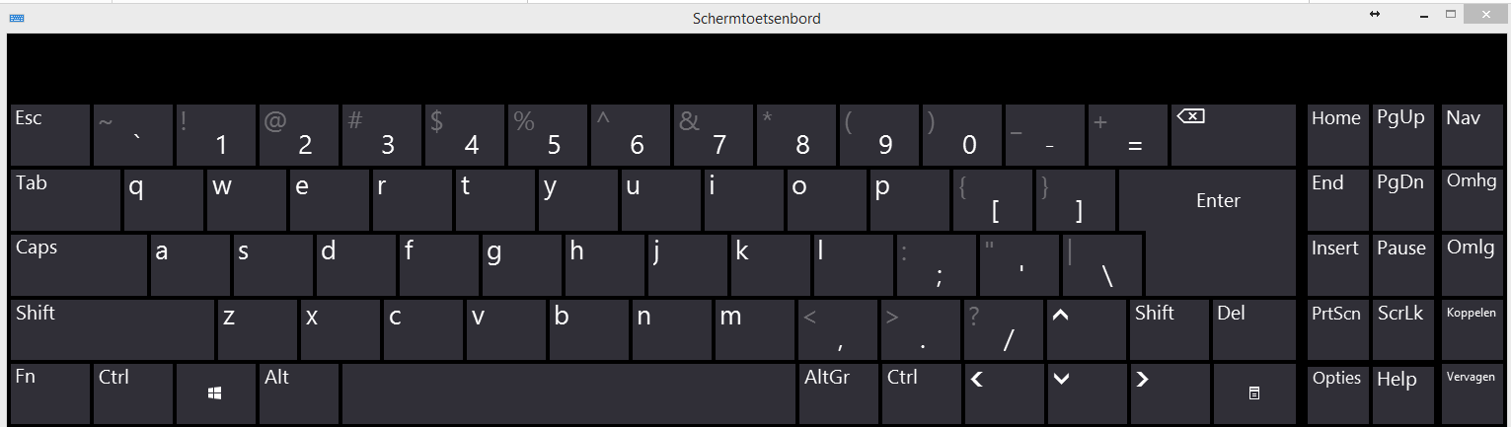

Figure 9‑2: On Screen Keyboard

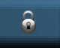

With this button you can switch between the different users on the system. NavVision starts with the chosen user. When set, a password is needed.

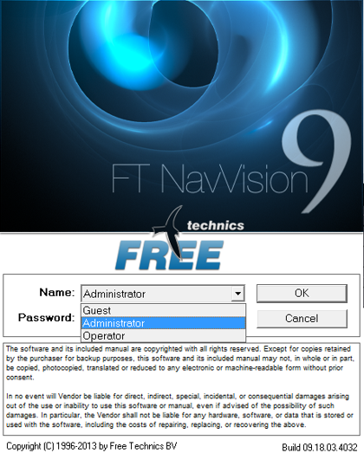

Figure 9‑3: User panel

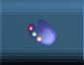

With this button you can switch between daytime, dawn and night mode. With the palette you can change each color for the different modes. NavVision starts default with the chosen colors. You can change that to your own scheme.

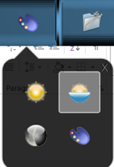

Figure 9‑4: Palette drop-down

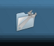

With this button you can show all the mimics available on the system. By clicking on one of the mimic-icons in the sub-field, you open the mimic. (See chapter 9.2).



This button opens the group viewer. In the group viewer you can see all the elements and their dependencies within the system, sorted by categories.

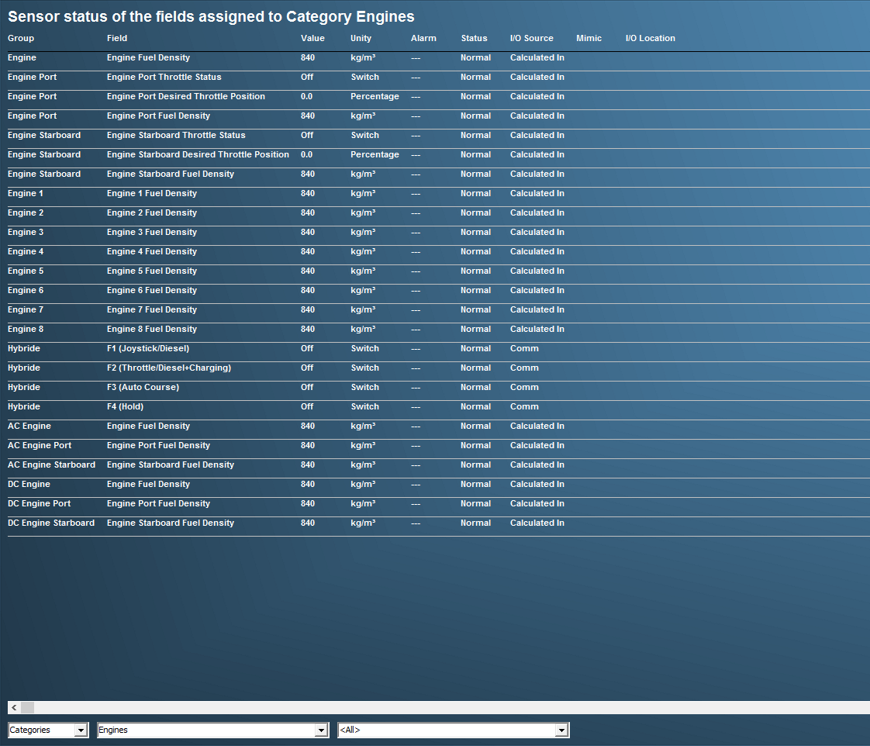

Figure 9‑5: Group viewer window



This button opens the alarm viewer. The alarm viewer will always be on top of all the other viewers, so you have to switch it off by hand. Depending on the settings in the Alarm-matrix it will show alarms and give the possibility to set deadman alarms, call other stations and select duty. (See chapter 10).

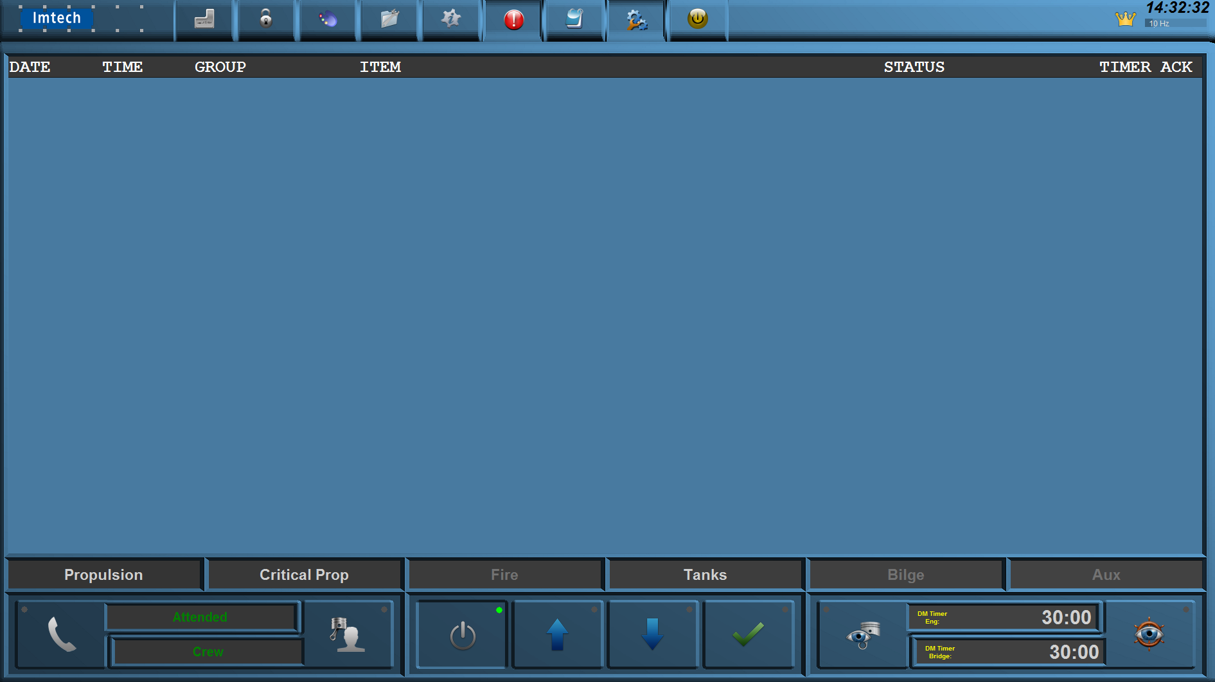

Figure 9‑6: Alarm mimic



This button will show the logbook. Here, every action and every alarm will be logged. It will give troubleshooting capabilities as well as reference. (See chapter 11.3).



This button will shut the AMCS system off

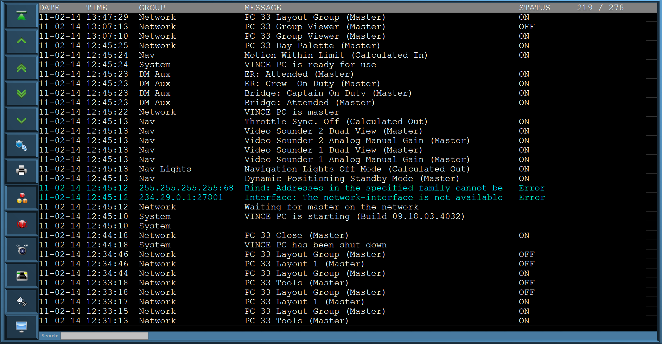

Figure 9‑7: Logbook mimic

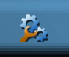

This button will open the settings area. Here you will find all the setting variables that are available. This will be discussed in diverse other manuals.

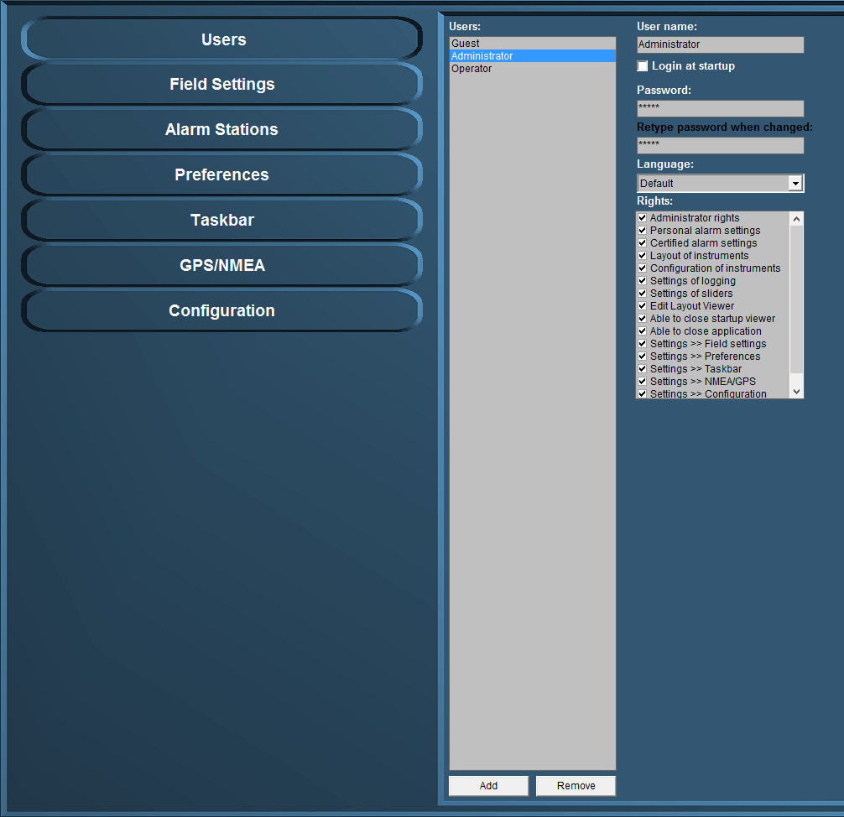

Figure 9‑8: Settings window

# Mimics

The NavVision mimic presentation function provides schematic and graphical overviews of the vessel’s systems like navigation lights, electrical, piping and hydraulic overview.

The screens and mimics presentations are automatically updated with live data of the platform components illustrating components and/or system status.

Via these mimic pages, the operator is able to monitor and control the vessel by using the trackball or touch-screen as a pointing device by selecting elements and their associated commands.

### Free adjustable mimics

We will focus here on the free adjustable mimics. Depending of the license the client bought, you can have as many mimics as you like. They are represented in the taskbar under the mimic button (see Figure 9‑9). Once you open that you can choose the mimic number and an empty mimic will appear (see

Figure 9‑10).

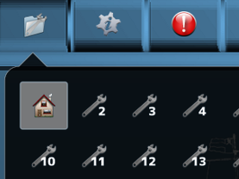

Figure 9‑9: Mimic button taskbar

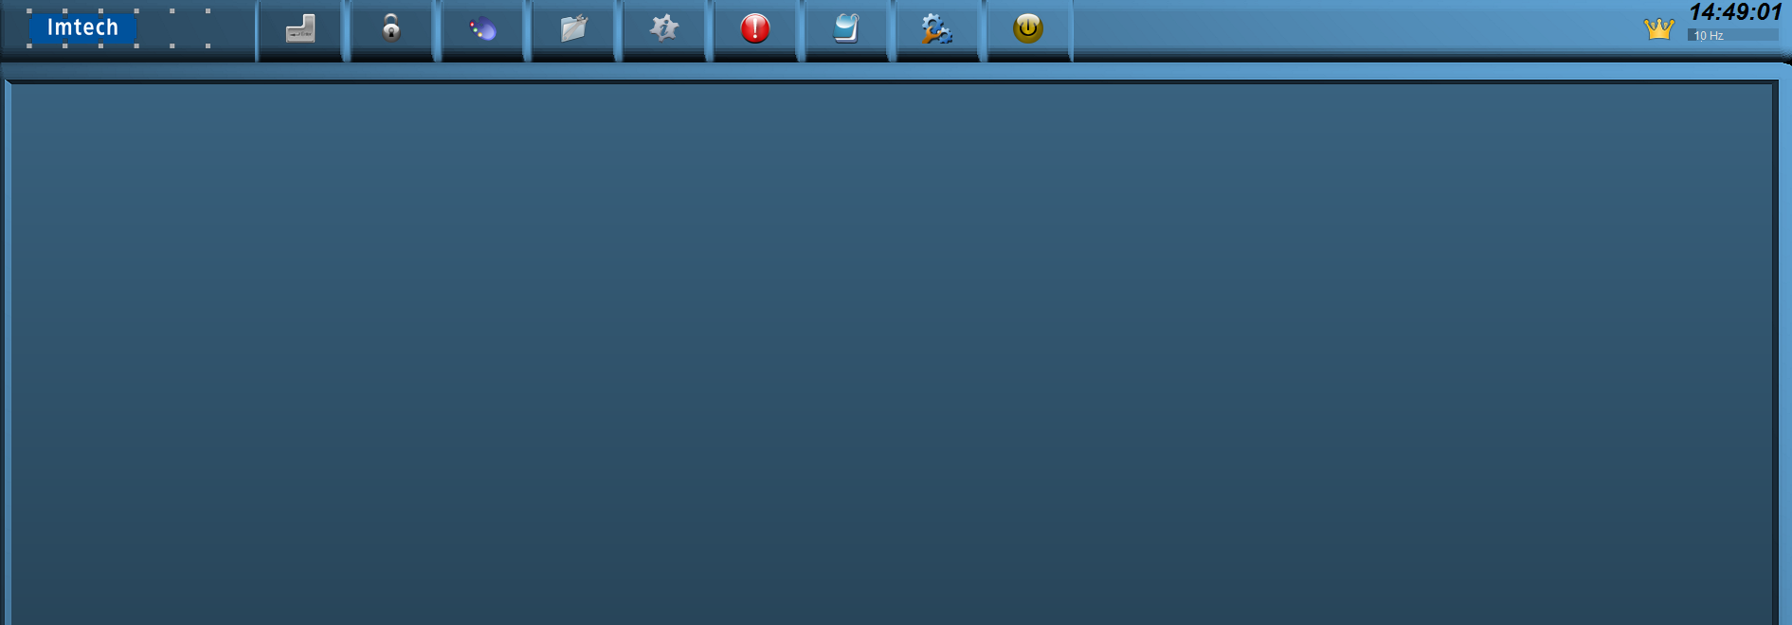

Figure 9‑10: Empty Mimic

#### Building the mimic

To start building the mimic you can right-click anywhere on the empty mimic. There will be an option to choose to open the edit mode (see Figure 9‑11). Once opened you get a new window (see Figure 9‑12).

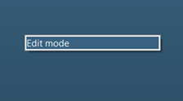

Figure 9‑11: Edit Mode

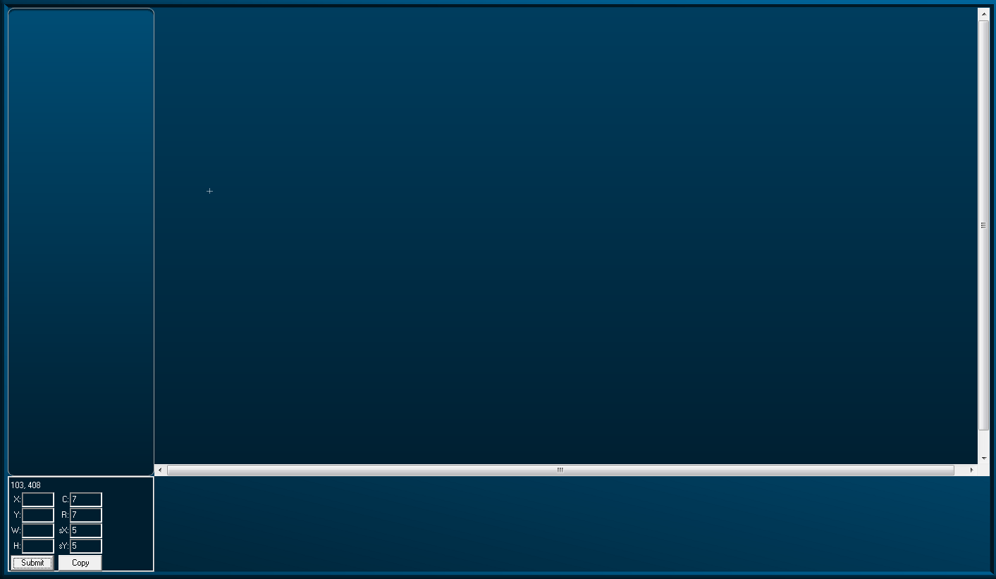

Figure 9‑12: Edit Mode Window

Right-clicking again will give you a window with all the options you have to build the mimic (see Figure 9‑13).

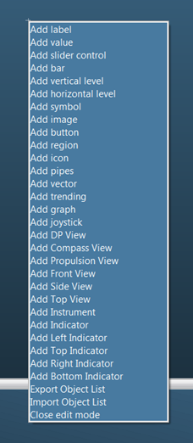

Figure 9‑13: Mimic Option Window

|  |  |
| --- | --- |
| **Option** | **Explanation** |
| Add Label | A Label is a text frame |
| Add Value | Any value that is given by a sensor |
| Add Slider Control | A slider to control settings to any output |
| Add Bar | A bar without index |
| Add Vertical Level | Vertical Level Bar |
| Add Horizontal Level | Horizontal Level Bar |
| Add Symbol | Choose a NavVision symbol |
| Add Image | Choose any image |
| Add Button | Button to trigger events |
| Add Region | Region to divide separate spaces |
| Add Icon | On/Off icon for indication |
| Add Pipes | Pipes to show ships piping system |
| Add Vector | Vector |
| Add Trending | Trending page (freely adjustable) |
| Add Graph | Graphic visualization of data |
| Add Joystick | Joystick for control |
| Add DP View | Dynamic view of ship for DP |
| Add Compass View | Show compass |
| Add Propulsion View | Propulsion |
| Add Front View | For DP |
| Add Side View | For DP |
| Add Top View | For DP |
| Add Instrument | Instrument for data sensors |
| Add Indicator | Small indicator mostly for engine data |
| Add Left Indicator | Variation on indicator |
| Add Top Indicator | Variation on indicator |
| Add Right Indicator | Variation on indicator |
| Add Bottom Indicator | Variation on indicator |
| Export Object List | Export tool for assigning mimic |
| Import Object List | Import tool for assigning mimic |
| Close Edit Mode | Close the editing mode |

Table 9‑1: Mimic options

*:* *Possibly not all options are available due to license issues*

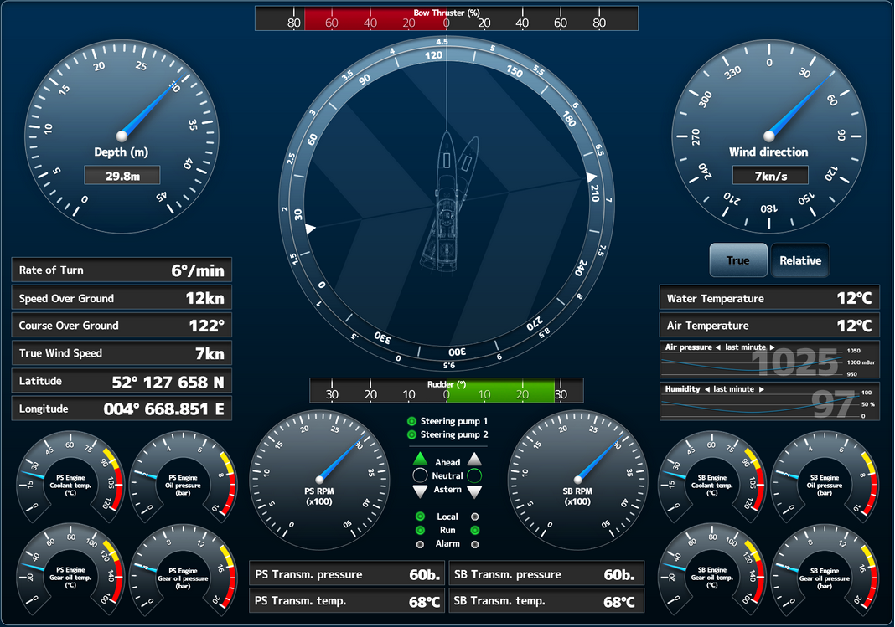

Figure 9‑14: example mimic options

It is beyond the scope of this document to elaborate too much on the mimics. For extensive explanation of working with mimics, please refer to the separate mimic manual. For general knowledge we will explain some basic features of standardization in mimics.

### Mimic color usage

Platform statuses are preferably to be visualized to remote operators by using animation i.e. by changing the relevant symbol color and/or symbol shape an operator will be able to interpret statuses much easier rather than by *reading text* strings or by interpreting numbers. This section defines colors and shapes relevant for the majority of platform objects frequently being used on a ship’s platform.

### Colour coding

Mimics will use the following color set for pipeline circuits and static (non-animated) symbols:

|  |  |  |  |  |
| --- | --- | --- | --- | --- |
| **Color** | **RGB** | | | **Medium description** |
|  | **RED** | **GRN** | **BLU** |  |
| **Brown** | 195 | 65 | 0 | Fuel oil |
| **Olive** | 128 | 128 | 0 | Lubrication oil |
| **Dark green** | 0 | 128 | 0 | Sea water, ballast water, fire main system |
| **Teal blue** | 0 | 128 | 128 | Low temperature fresh water (cooling water and potable water) |
| **Aqua blue** | 0 | 255 | 255 | High temperature fresh water (cooling water and potable water) |
| **Grey** | 128 | 128 | 128 | Bilge water, hydraulics, grey/black water |
| **Bright green** | 0 | 255 | 0 | Electrical distribution – Medium Voltage |
| **Orange** | 255 | 102 | 0 | Electrical distribution – High Voltage |
| **White** | 255 | 255 | 255 | ventilation air, exhaust gas |

Table 9‑2: Color markings of pipes

### 

### Symbols

To learn about animated symbols you must be familiar with the basics of element processing first. Platform objects can be classified regarding their interface with the AM(C)S and functional behavior into so called, element types.   
In this way it is possible to distinguish between a sensor element type, valve element type, motor element type, etc. Once the platform objects are classified into element types the applicable mimic symbol for each platform object can also be specified since the element types identify the relevant monitoring and control abilities.

However mimics not only comprise of animated objects. For instance in case a platform object is not involved with alarm monitoring and control features at all then from the AM(C)S point of view it makes no sense to comprehend this object.   
Still these objects might be displayed in mimics as static (i.e. not animated) to improve clarity. The set of static symbols in NavVision is based on nowadays widely accepted icons being used in system diagrams and P&ID[1] drawings. Static symbols will be drawn in the color of the applicable medium.

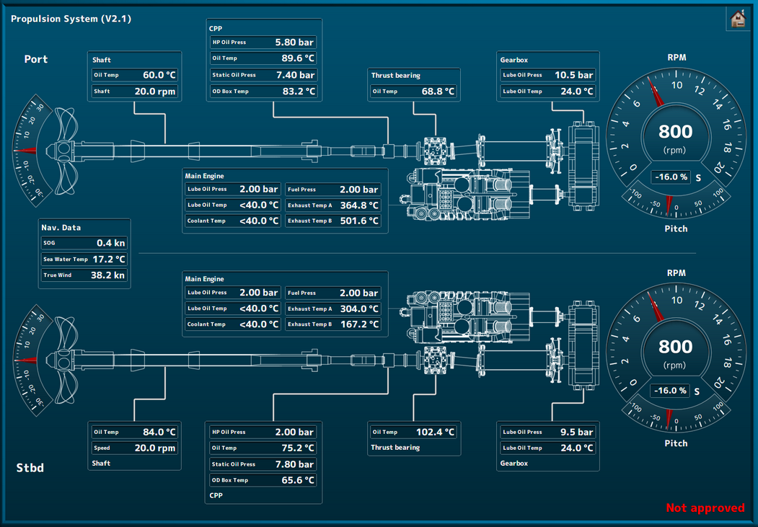

Figure 9‑15: Mimic layout

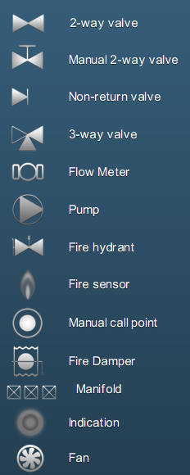 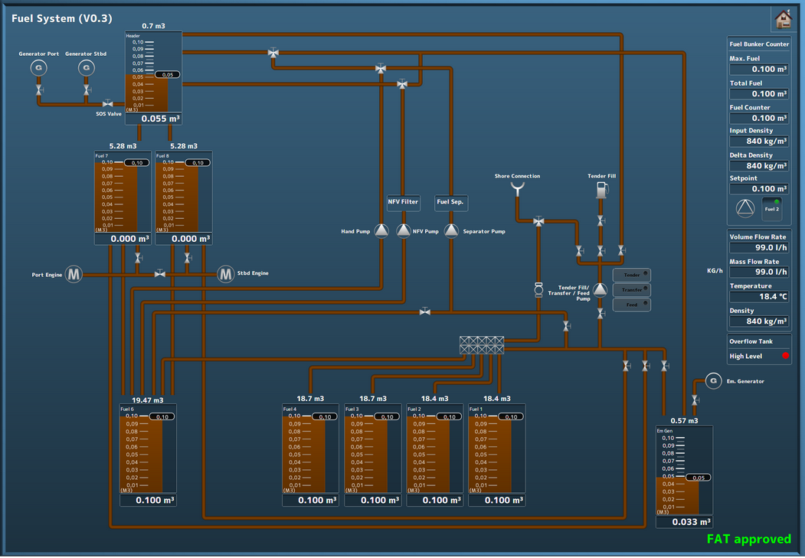

Figure 9‑16: Symbol examples

Piping is used for indication and/or connection purpose, but can also be active. The color-coding is dictated by international rules for standardization. When piping is overlaying but not connected, this must be shown clearly by interruption of the piping at the horizontal line.

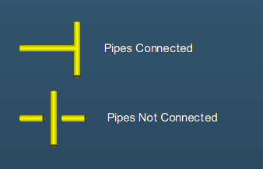 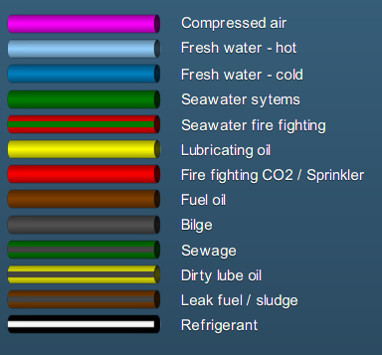

Figure 9‑17: Piping intersection and color

Color usage is possible in two different colors. There is an inside and an outside color available. This way we can live up to international rules.

Piping color is also interactive. You can connect the behaviour of an element to the color of the piping. This way it is possible that you show different setups at the same piping. If you use them for example for power lines, you can color it white when not active and green when active.

### Control elements

Control elements are used to interface a wide range of “Control” devices like pumps, fans, valves, generators, etc. via their relevant starter unit. Since these element types are suitable to process a wide range of components, several symbols are defined to represent each type.   
Color animation is used to show the actual element status.

Chevrons, a single filled chevron (arrow) for low - and a double filled chevron (arrow) for high speed, show the difference between a control element running at high speed and a control element running at low speed. Chevrons without filling indicate an off condition.

|  |  |  |
| --- | --- | --- |
| **Status** | **Control element** | **Symbol** |
| Operable in two speeds, system off | Double chevron (no fill) |  |
| Operable in two speeds, system running at low speed | Double chevron  (single chevron filled) |  |
| Operable in two speeds, system running at high speed | Double chevron  (double chevron filled) |  |
| Operation is disabled (local control only or controlled by other OPC) | Padlock |  |
| Manual operation (controlled remotely) | Hand |  |
| Automatic operation (controlled by ACS[2]) | Chip |  |

Table 9‑3: Control element status

|  |  |
| --- | --- |
| **Colour** | **Description** |
| **Grey** | Control element off (stopped), device is ok |
| **Green** | Control element on (running), device is ok |
| **Orange** | Control element in warning condition |
| **Purple** | Control element defective |
| **Red** | Control element in alarm condition |

Table 9‑4: Color codes (control elements)

### Pump and generator control elements

|  |  |  |  |
| --- | --- | --- | --- |
| **Centrifugal pump** | **Piston pump** | **Generator** | **Status description** |
|  |  |  | OFF |
|  |  |  | ON (condition ok) |
|  |  |  | ON, WARNING condition |
|  |  |  | ON,  DEFECTIVE condition |
|  |  |  | ON,  CRITICAL condition |

Table 9‑5: Control elements and color animation

### 3-Way valve control element

|  |  |  |  |
| --- | --- | --- | --- |
| **3-way valve OFF** | **Status description** | **3-way valve ON** | **Status description** |
|  | 3-way valve OFF (status indication only) |  | 3-way valve ON (status indication only) |
|  | 3-way valve OFF, AUTO  (control by AMCS[3]) |  | 3-way valve ON, AUTO  (control by AMCS) |
|  | 3-way valve OFF, AUTO  (local control) |  | 3-way valve ON, AUTO  (local control) |
|  | 3-way valve OFF  (local control) |  | 3-way valve ON  (local control) |
|  | 3-way valve OFF, MANUAL  (controlled by AMCS) |  | 3-way valve ON, MANUAL  (controlled by AMCS) |
|  | 3-way valve OFF, MANUAL (local control) |  | 3-way valve ON, MANUAL (local control) |

Table 9‑6: Control elements with status indication

### Other control options

|  |  |
| --- | --- |
| Pump Status | Description |
|  | Centrifugal pump ON,  Operable in two speeds, system off |
|  | Centrifugal pump ON,  Operable in two speeds, pump running at low speed |
|  | Centrifugal pump ON,  Operable in two speeds, pump running at high speed |

Table 9‑7: Control elements with speed indication

|  |  |  |
| --- | --- | --- |
| Element off | Element on | Description |
|  |  | Fan OFF and ON |
|  |  | 2-way valve OFF and ON |
|  |  | Check valve OFF and ON |

Table 9‑8: Other control elements

# Duty alarm system and alarm handling

## Introduction

The duty alarm system provides machinery alarms to bridge, cabins and public areas for an unattended (unmanned) machinery space. The duty alarm system will be configured from a particular Operator Work Station (OWS).

Duty Alarm Panels (DAPs) at each location are connected with the automation system via the system network.They display the information for machinery alarms and settings such as alarm group status, operation status, and on-duty selection.

The duty alarm system provides for signaling of Engine Control Room (ECR) to the cabins and bridge. An engineer on duty can be selected from the Operator Workstation (OWS) in the machinery space. He will be warned when an essential alarm is present in the unmanned engine room.

A watch safety timer on the workstation monitors the engineer working in the engine room.

When the engineer does not acknowledge within 30 minutes, the relevant engineers alarm is invoked, warning all engineers and bridge.

: *For more detailed information on “manned” and “unmanned” systems we refer you to the appropriate manuals.*

The “On duty” selection, “Call”, “Unattended” and “Attended” functions are implemented on the Alarm mimic.

In general an alarm comes with visible and audible notifications.

The duty alarm system distinguishes two different alarm modes i.e.:

* Attended alarm mode
* Unattended alarm mode

## Design principle

### Alarm groups

All alarms monitored values are divided into alarm groups. Alarms belong to a specific alarm group (see Figure 10‑1). Active alarms are indicated by a flashing light (unacknowledged alarm) or steady light (acknowledged alarm).

The alarm messages are displayed on top of the screen and can be scrolled by means of the

Scrol-buttons (See Figure 10‑2).

**ݫ°**

Figure 10‑1: Alarm groups



Figure 10‑2: Alarm scroll buttons

### Alarm types

#### Alarm detection for analogue signals

The following functions are included:

* Instrument failure alarms
* Low-low process alarms with or without action (slow-down)
* Low process alarms
* High process alarms
* High-high process alarms with or without action (slow-down)
* Return to normal detection with dead-band to avoid alarm fluctuations
* Adjustable filter factors to filter fluctuations in the incoming signals
* Time delay of alarm triggering and return to normal messages.

#### Alarm detection for on/off (two state) signals

The following functions are included:

* High process alarms
* Return to normal detection
* Time delay of alarm triggering and return to normal messages.

#### Alarm detection for on/off signals with line check

The following functions are included:

* High process alarms (open or closed)
* Line broken alarm
* Line short alarm
* Return to normal detection
* Time delay of alarm triggering and return to normal messages.

### Alarm inhibits

Some alarms are conditional and will be inhibited when a specific condition is present. This function is accomplished by defining a signal as an inhibit source for a specific alarm or a specific group of alarms. This will show in the Alarm page (see Figure 10‑3).

### Attended alarm mode

NavVision will transfer the alarm to the activated location.

In case of an attended or manned machinery space this location will be the:

* Engine Control Room (ECR)
* Accommodations (e.g. mess room and public areas).

### Unattended alarm mode

In case the operator is not present in the machinery space, the duty can be forwarded to a panel or workstation where the engineer on duty is residing. Within this period of time, alarms that are present are visible on selected Duty Alarm Panels (DAPs).

The “Unattended” mode can be activated on the workstation that has control over the sensor alarm group. Activation of the unattended machinery space mode can only be done when all alarms are acknowledged.

NavVision will direct the alarm to the activated location.

In case of an unattended or unmanned machinery space this will be:

* The engineer on-duty
* Accommodations (e.g. mess room and public areas).

When a sensor alarm group is unmanned in “Unattended” mode, new alarms are indicated on the DAP of the engineer. On the panels, the alarm sounding (horn/buzzer) can be silenced (only local), but the alarms still need to be acknowledged on the OPC within the relevant technical area.

If alarms are not acknowledged within a specific period of time on the OPC in-control, the “General Engineers Alarm” (GEA) is invoked, independent from the “Attended/Unattended” mode. Once the GEA goes off, the alarm will sound on all alarm stations

### How an alarm is displayed

|  |  |
| --- | --- |
| **Panel** | **Alarm displayed** |
| Duty Alarm Panel (DAP) | On main screen |
| Operator Work Station (OWC) | On taskbar  On alarm viewer  In logbook  On any mimic showing the field-in-alarm |

*: The alarm viewer on the OWS uses the same layout as the DAP, thus making it easier for an operator to understand and operate the screen.*

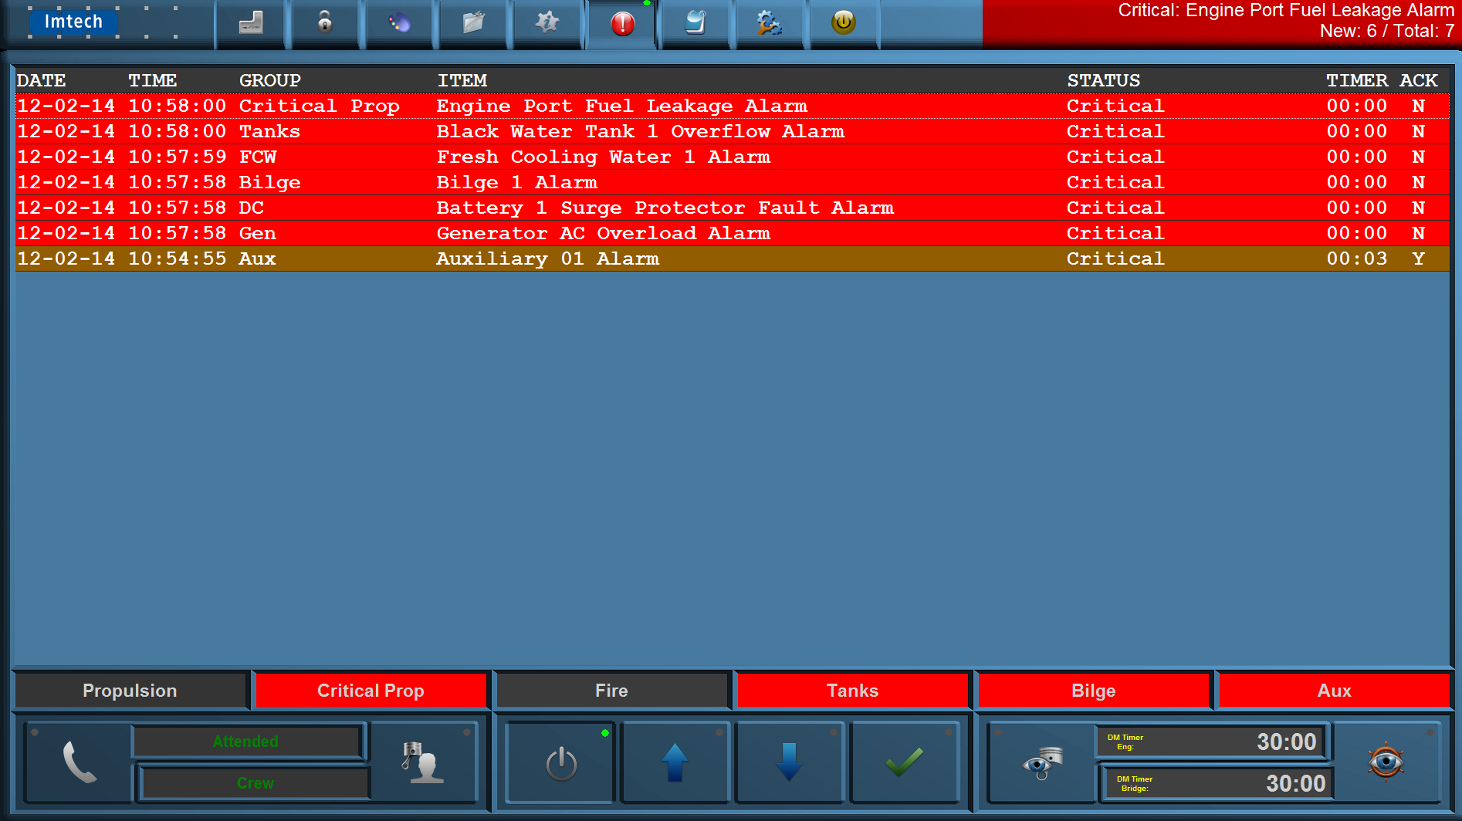

Figure 10‑3: Alarms on alarm viewer and taskbar

### How to acknowledge an alarm

The alarms must be acknowledged on the Operator PC (OPC) in the Engine Control Room (ECR) by means of:

* Double clicking the corresponding alarm line (alarm viewer)
* Double clicking the field (when red) in the MIMIC showing the field-in-alarm.

### When an alarm is not acknowledged within a specific period of time

The General Engineers Alarm will sound on all alarm stations, until it is accepted / acknowledged, in which case the alarm goes off.

Any unacknowledged alarm is always shown on top of the acknowledged alarms of the alarm viewer (incl. DAP) and will be flashing red.

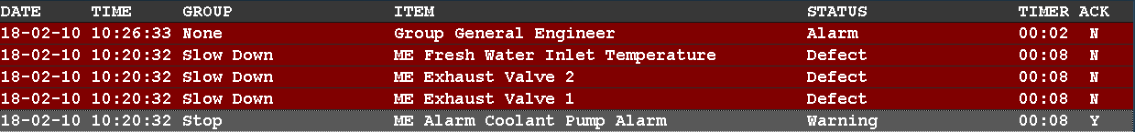

Figure 10‑4: One acknowledged and three unacknowledged alarms (incl. GEA)

### How to silence an alarm (not at ECR)

You can silence an alarm on all other locations.

This will silence the alarm buzzer for 3 minutes, but will not acknowledge the alarm.

The engineer is required to go to the Engine Control Room (ECR) to acknowledge the alarm.  
On other systems, silencing the alarm is also called an “audible acknowledge”. We will however use the term “silencing” throughout all of our documentation.

### When will an alarm disappear

An alarm will disappear only when rectified AND acknowledged. Acknowledged alarms will show in the normal instrument colour. (See Figure 10‑5Figure 10‑4).

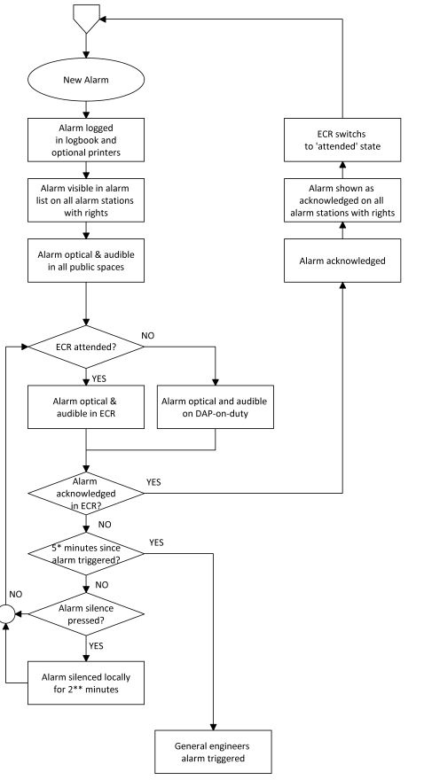

Figure 10‑5: typical alarm sequence

### 

### Controls and indications

The on-duty selection, call, attended and unattended functions are implemented on a dedicated mimic. The on-duty mimic can be called up by selecting one of the two buttons at the bottom of the screen

1. Call button
2. On-duty indication
3. Duty select button.

1

3

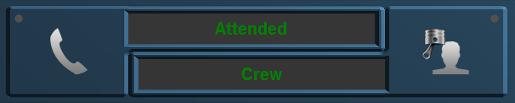

2

Figure 10‑6: Call button / on-duty indication / duty select button

#### Call button

From the duty alarm panel it is possible to call for a specific area (e.g. bridge or engine room), engineer or all engineers.

Press the “Call button” (see Figure 10‑6), the call indicator will lit, and the selected area or engineer is called.

To cancel the call, push the “Call button” again.

#### On-duty indication

Press the “ATTENDED” button to signal that the engine control room is manned.

Press the “UNATTENDED” button to signal that the engine room is unmanned.

Via the “Duty select button” (see Figure 10‑6) the responsible engineer (on-duty engineer) can be selected and will be displayed on the display (“On-duty indication”).

#### Duty select button

Push the “Duty select button” (see Figure 10‑6) and select the responsible engineer. The “On-duty indication” displays the responsible engineer.

#### Panel active button

The switch-on or switch-off the duty alarm panel. When duty is selected it is automatically turned on. Other stations can chose if they want to hear the alarms by switching their station on or off.



Figure 10‑7: Panel active button

#### On-duty selection

The on-duty mimic contains duty selection and call buttons. In addition, the selection attended/unattended can be made.

The “Bridge watch safety timer”, “Engine room watch safety timer” (see Figure 10‑8) including the “Engine room watch active button” and “Bridge watch active button” are also implemented on the server (dead man’s watch).

At the bottom of the screen, the state of the watch safety timer is displayed:

* When the engine room is UNATTENDED, the engine room watch safety timer is “OFF”   
  When the engine room is ATTENDED, the engine room watch safety timer is “ON” (remaining time is counting down).

#### Watch safety timer

The watch safety timer (DM Timer[4]) remaining time is displayed at the bottom of each screen on the workstation. The timer counts down from 30 minutes back to 0 minutes.

When the timer reset has not taken place and the 3 minutes pre-alarm limit is reached, an alarm occurs on the workstation that no “Reset” button has been selected within the last 27 minutes.

The watch safety timer “Remaining time” indication (see Figure 10‑9) displays now in a red.

When selecting the “General Engineers Alarm” (GEA) button, or after countdown to 0 minutes (3 minutes warning cycle has passed) this means that the “Reset” button has not been selected within the last 30 minutes and the GEA is invoked.

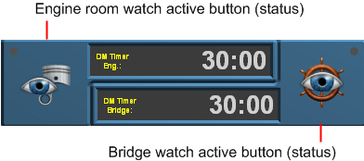

Figure 10‑8: Watch safety timer

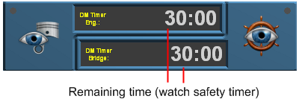

Figure 10‑9: Watch safety timer (remaining time indication)

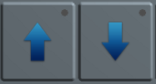

Figure 10‑10: Operating buttons



Figure 10‑11: Acknowledge button

## On duty select procedure

An engineer on duty can be selected on duty from the allocation control button on the Duty Alarm Panel (DAP). The engineer will be warned when an alarm is present in one of the “Unmanned” alarm groups. Using the alarm panel of the engineer on duty, the engineer is notified of new alarms. This is done by warning light, buzzer and/or on-screen functions. Alarms are always represented on the screen.

The duty alarm system sends alarms to the responsible persons in case of incorrect situations whenever the machinery spaces are unattended. The release procedure for duty alarms will be done (before leaving the area) at the main Operator PC (OPC) in the Engine Control Room (ECR).

## Alarm acknowledge procedure

If during watch free operation an alarm occurs the normal procedure will be that the engineer on duty will receive an optical and acoustic alarm in his cabin. Accordingly he must Silence the alarm on his panel.

The alarm itself is still in the status not acknowledged. The engineer on duty must go to the ECR, to acknowledge the alarm and solve the problem in the control room.

When the engineer on duty ignores the alarm in his cabin, a repeat alarm function will be activated. This means, after a specific period of time the duty alarm system generates a General Engineer’s Alarm (GEA) on all stations.

## Call function

From the Duty Alarm Panel (DAP) it is possible to call for a specific engineer, bridge or all engineers (see **Error! Reference source not found.**).

# Personnel alarm

## General

A personnel alarm provides a safety timer (see **Error! Reference source not found.** and **Error! Reference source not found.**) for personal protection, used when a single person works in an unattended area. The personnel alarm consists of:

* A release station
* Acknowledge stations

### Release station

The release station is used to indicate whether a machinery space is “Attended” or  
“Unattended” and is preferably situated at the entrance of the machinery space. The release station consists of the following buttons i.e.:

* A “attended/unattended” push button
* A timer “active/inactive” button
* A alarm “active/silence” push button

|  |  |
| --- | --- |
| **Button** | **Detail** |
| Attended | Press when entering the machinery space to activate and when leaving to deactivate. |
| Timer | The safety timer can be deactivated (disabled) by using the workstation in the machinery space in conjunction with the right Password (see Figure 11‑1) |
| Alarm | Shows when the station is in alarm. Can be pressed to silence the alarm, which inheritably will reset the Timer. |

Table 11‑1: Release station buttons

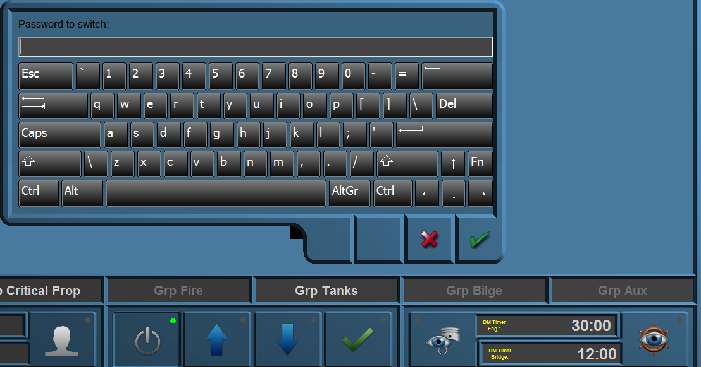

Figure 11‑1: Deadman Switch Password

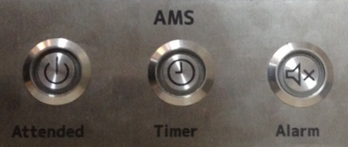

Figure 11‑2: Release station

### Alarm Panel

In order to acknowledge alarms to persons on duty an Alarm Panel is used (this panel can also be used in public spaces and on the bridge).   
The Alarm Panel consists of three buttons, the “Dim” button, the “Timer Button” and the “Alarm Button”. These buttons have a combined function i.e. button and lamp (see Figure 11‑3).

|  |  |
| --- | --- |
| **Button** | **Detail** |
| Dim | cycle through diverse states of brightness for all the LED’s |
| Timer | shows if the Deadman Timer is activated and has no push-function |
| Alarm | Shows with the LED if there is an active alarm. By pressing the button you can silence the panel’s buzzer for three minutes. |

Table 11‑2: Alarm Panel

The Alarm Panel consists of hardwired buttons with LED[5] lighting.

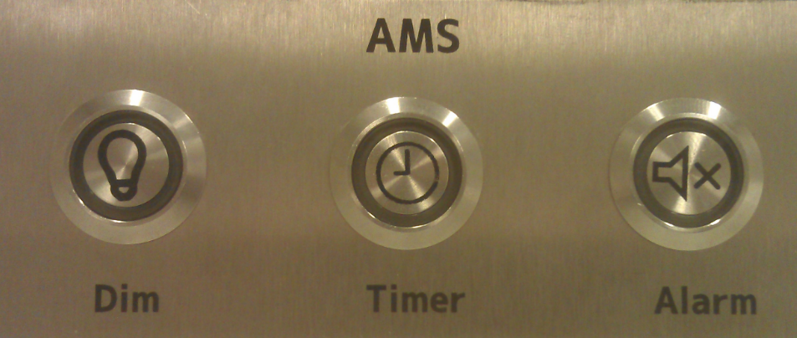

Figure 11‑3: Alarm Panel

### BNWAS

The BNWAS (Bridge Navigational Watch Alarm System) is also a personal safety system but then mend to be used on the bridge. You can use it the same way as the entrance module (see **Error! Reference source not found.** and Figure 11‑1). The BNWAS panel (see Figure 11‑4) consists of the following buttons:

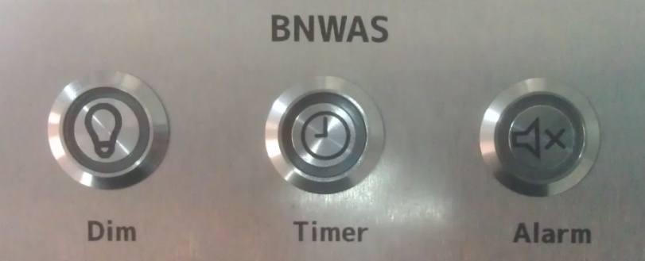

Figure 11‑4: BNWAS Panel

|  |  |
| --- | --- |
| **Button** | **Detail** |
| Dim | cycle through diverse states of brightness for all the LED’s |
| Timer | shows if the Deadman Timer is activated and has no push-function |
| Alarm | Shows with the LED if there is an active alarm. By pressing the button you can silence the panel’s buzzer for three minutes. |

Table 11‑3: BNWAS

## Alarm monitoring and control process

|  |  |
| --- | --- |
| **Step** | **Detail** |
| 1 | The Alarm, Monitoring and Control System (AMCS) detects when a person enters a machinery space via the switch on the “Release station” in or near the machinery space. |
| 2 | After 27 minutes an audible or visual alarm will be initiated by the system in the appropriate machinery space to prompt the engineer to reset the safety timer. |
| 3 | During each period of 30 minutes the person working alone in that space must reset the safety timer to confirm his presence/well-being. A “Reset” command must be given via the reset button on the “Timer reset station”, the workstation or on one of the mushroom buttons in that particular machinery space.  Each space has its own safety timer. |
| 4 | If the “Reset button” is still not pressed within 3 minutes after the warning, a general alarm will sound on all the workstations. |

Table 11‑4: Alarm monitoring and control process engineer

|  |  |
| --- | --- |
| **Step** | **Detail** |
| 1 | The Alarm, Monitoring and Control System (AMCS) detects when a person is on watch in the wheelhouse via the switch on the “Release station”. |
| 2 | After 12 minutes an audible or visual alarm will be initiated by the system in the Wheelhouse to prompt the officer to reset the safety timer. |
| 3 | During each period of 12 minutes the person working alone in that space must reset the safety timer to confirm his presence/well-being. A “Reset” command must be given via the reset button on the “Timer reset station”, or at the workstation. |
| 4 | If the “Reset button” is still not pressed within 3 minutes after the warning, a general alarm will sound on all the workstations. |

Table 11‑5: Alarm monitoring and control process BNWAS

# Logbook

޵°

Figure 11‑5: Logbook button

### General

During normal operation all system events will be registered chronologically. By clicking the “Logbook” button (see Figure 11‑5) these registered system events can be displayed.

In order to easily distinguish the displayed information, logbook reports are divided into colours. These colours are explained as follows:

#### Logbook colours

* **White**Reports to indicate the system is busy processing data
* **Green**Reports to confirm a certain system task is successfully completed
* **Red**Reports to indicate a system error has occurred or an alarm is set off
* **Orange**Reports to indicate a red report has been confirmed or that a white or green report hasbeen interrupted
* **Blue**Reports to indicate that parts of the system have been initialized.

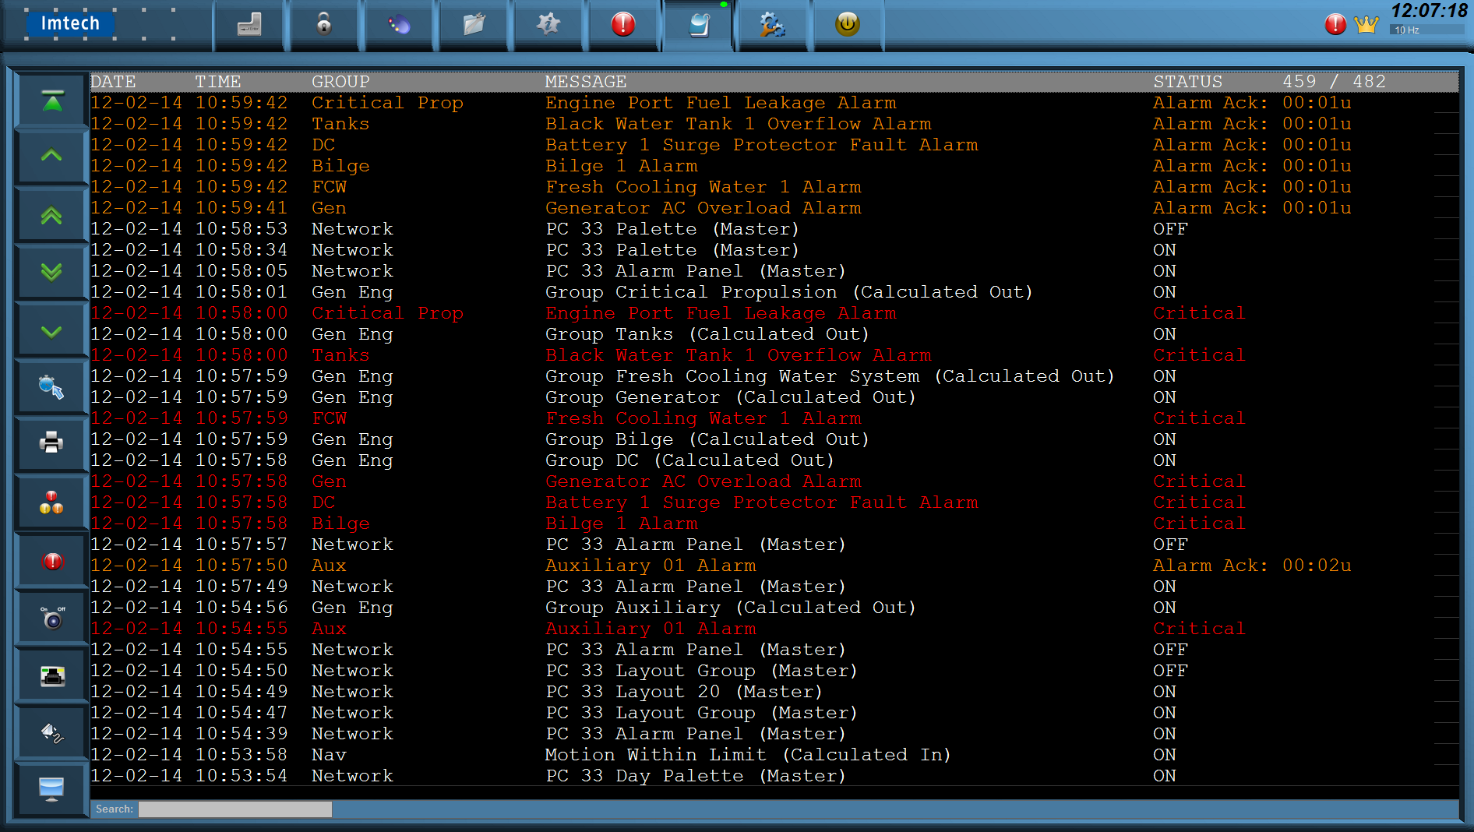

Figure 11‑6: Logbook colours

### Logbook functionalities

The logbook has the following functionalities:

* Navigation/scroll buttons
* Time period
* Alarms from all stations
* Alarms
* Switching
* Network
* Serial communication
* System.

### Buttons

#### Scroll buttons

The scroll buttons are used to navigate through the logbook. The scroll buttons are explained as follows:

ݫ°

Figure 11‑7: Scroll buttons

|  |  |
| --- | --- |
| **Button** | **Description** |
| Scroll up/down (single) | To scroll up or down (one line at the time) the report list |
| Scroll up/down (double) | To scroll up or down (per page) the report list |
| Auto scroll | * ON The system event list is automatically scrolled with every new incoming event. * OFF The system event list freezes. |

#### Time period button

The “Time period” button allows you to define the view period (time frame) of all entries to be displayed.

ݫ°

Figure 11‑8: Time period button

#### Alarms from all stations button

By selecting the “Alarm from all stations” button all alarm messages are shown, that are monitored by NavVision® including the alarm messages not related to this alarm station.

ݫ°

Figure 11‑9: Alarms from all stations button

#### Alarm button

By selecting the “Alarm” button all assigned alarm station messages are shown.

ݫ°

Figure 11‑10: Alarm button

#### Switching button

By means of the “Switching” button all fields that are being switched by NavVision® are displayed (i.e. hard/soft wired I/O or the switching of viewers).

ݫ°

Figure 11‑11: Switching button

A typical logbook entry is shown below (column “Message”):

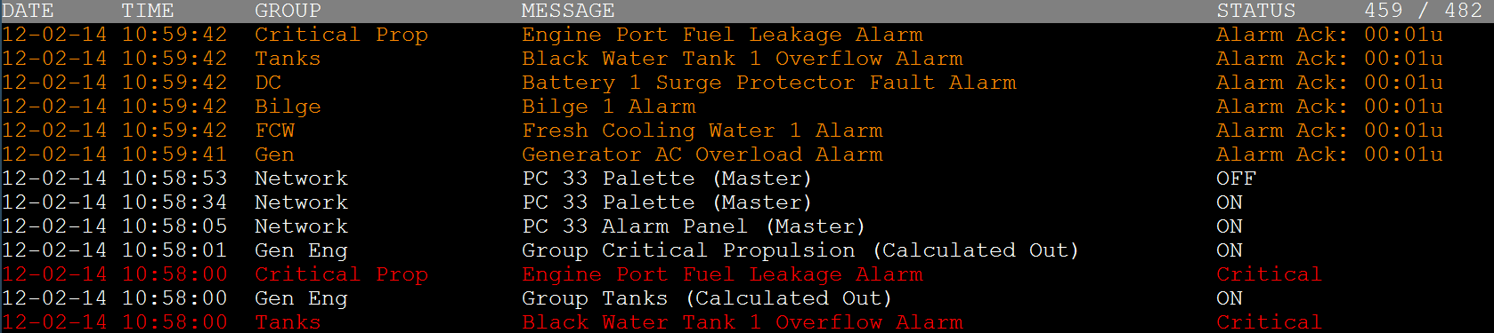

|  |  |
| --- | --- |
| **Column** | **Description** |
| Date | Date message occurred |
| Time | Time message occurred |
| Group | Group message belongs to |
| Message | Actual message |
| Status | Status of the message |

#### Network button

Each Ethernet network connection will be logged under network entries.

The following is shown:

ݫ°

Figure 11‑12: Network button

* **White**  
  When a system tries to connect to a device
* **Green**  
  When the system successfully establishes a connection with a device
* **Red**  
  System fails to connect to a device or  
  Connection with a device has been interrupted or  
  General network error has occurred.

#### Serial communication button

By selecting the button “Serial communication” the history of all serial communication systems is shown.

ݫ°

Figure 11‑13: Serial communication button

* **White**  
  The system tries to create a (local) serial connection or initializes a serial protocol instance
* **Green**  
  The system successfully created a serial connection
* **Red**  
  A serial connection error has occurred.

#### System button

Via the “System” button system information messages in general are shown.

ݫ°

Figure 11‑14: System button

* **Green**  
  Successful process start
* **Red**  
  A serious problem has occurred in the process.

**Appendix A**

**Sensortype**

**SensorType** defines which subfield or action of the Data Field is set by this value. By default it’s [Standard]. Standard means it’s not defining a subfield or action, but the value of the Data Field itself.

|  |  |  |
| --- | --- | --- |
| SensorType (Mode: Read) | | |
| Option | Sensor | Description |
| Standard | Value | Sensor value represents the state of the Data Field itself (Default) |
| Set | On | Request to turn on |
| Off | No action |
| Reset | On | Request to turn off |
| Off | No action |
| Pending | On | Processing a request. |
| Off | No action |
| Auto | On | Switched by an automatic control sequence |
| Off | Controlled by an operator |
| Manual | On | Controlled by an operator |
| Off | Switched by an automatic control sequence |
| Low Speed | On | Running at low speed |
| Off | Off, when not in “High Speed”. Otherwise no action |
| High Speed | On | Running at high speed |
| Off | Off, when not in “Low Speed”. Otherwise no action |
| Closed | On | Switched off |
| Off | Processing a request, when not “Open” |
| Open | On | Switched on |
| Off | Processing a request, when not “Closed” |
| Ready | On | Ready for use |
| Off | Not ready for use |
| Remote | On | Remote control. Controlled by AMCS |
| Off | Local control. Not controlled by AMCS |
| Ack | On | Acknowledgement of alarm on the assigned field |
| Off | No action |
| Request | On | Request to turn on |
| Off | Request to turn off |
| Push | On | Request to turn on, when off.  Request to turn off, when on. |
| Off | No action |
| Too Low | On | Value is too low |
| Off | Value is not too low |
| Low | On | Value is low |
| Off | Value is not low |
| High | On | Value is high |
| Off | Value is not high |
| Too High | On | Value is too high |
| Off | Value is not too high |
| Failure | On | Defect |
| Off | Not defect |
| Precision | On | High precision frequency counter in 0.01 Hz accuracy up to 10kHz |
| Off | Low precision frequency counter in 1 Hz accuracy up to 100kHz |
| Counter | Value | The changes in this counter value will be added to the field |
| Sign | On | The value read by “Standard” is negative |
| Off | The value read by “Standard” is positive |
| Index | Value | Value is the index of a serial message. See “Index” description |
| Pulse | On | Field’s value is counted 1 up |
| Off | No action |
| Pulse 1/2 | Value | Used in combination with “Pulse 2/2” to detect movement with two proximity switches. |
| Pulse 2/2 | Value |
| Pulse 1/3 | Value | Used in combination with “Pulse 2/3” and “Pulse 3/3” to detect movement with three proximity switches. |
| Pulse 2/3 | Value |
| Pulse 3/3 | Value |

|  |  |  |
| --- | --- | --- |
| SensorType (Mode: Write) | | |
| Option | Sensor | Description |
| Standard | Value | Requested state of the Data Field itself (Default) |
| Set | On | Request to turn on |
| Off | No action |
| Reset | On | Request to turn off |
| Off | No action |
| Pending | On | Processing a request. |
| Off | No action |
| Auto | On | Request to turn automatic control sequence on |
| Off | Request to turn automatic control sequence off |
| Low Speed | On | Request to run at low speed |
| Off | Request to turn off, when not in “High Speed”. Otherwise no action |
| High Speed | On | Request to run at high speed |
| Off | Request to turn off, when not in “Low Speed”. Otherwise no action |
| Impulse | On | Request to turn on, when off.  Request to turn off, when on. |
| Off | No action |
| Status | Value | Output value represents the state of the field/ device itself  (No control) |
| Ready | On | Ready for use |
| Off | Not ready for use |
| Remote | On | Remote control. Controlled by AMCS |
| Off | Local control. Not controlled by AMCS |
| Too Low | On | Value is too low |
| Off | Value is not too low |
| Low | On | Value is low |
| Off | Value is not low |
| High | On | Value is high |
| Off | Value is not high |
| Too High | On | Value is too high |
| Off | Value is not too high |
| Failure | On | Defect |
| Off | Not defect |

1. P&ID = Piping & Instrumentation Diagram
2. ACS = Automation Control Sequences
3. AMCS = Alarm, Monitoring and Control System
4. DM Timer = Dead Man’s Timer
5. LED = Light Emitting Diode